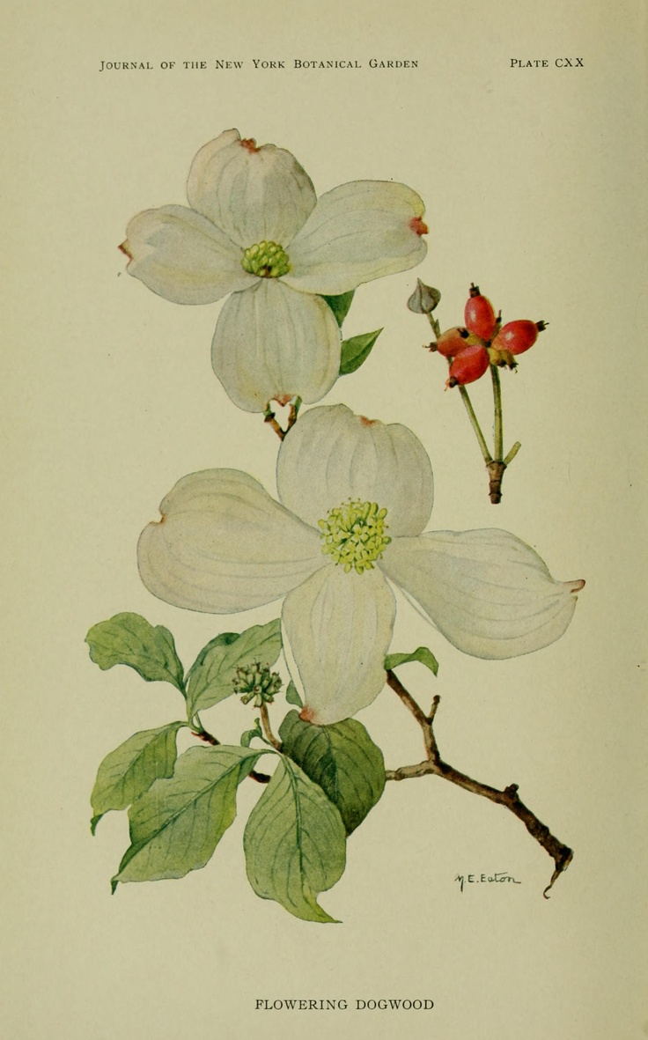
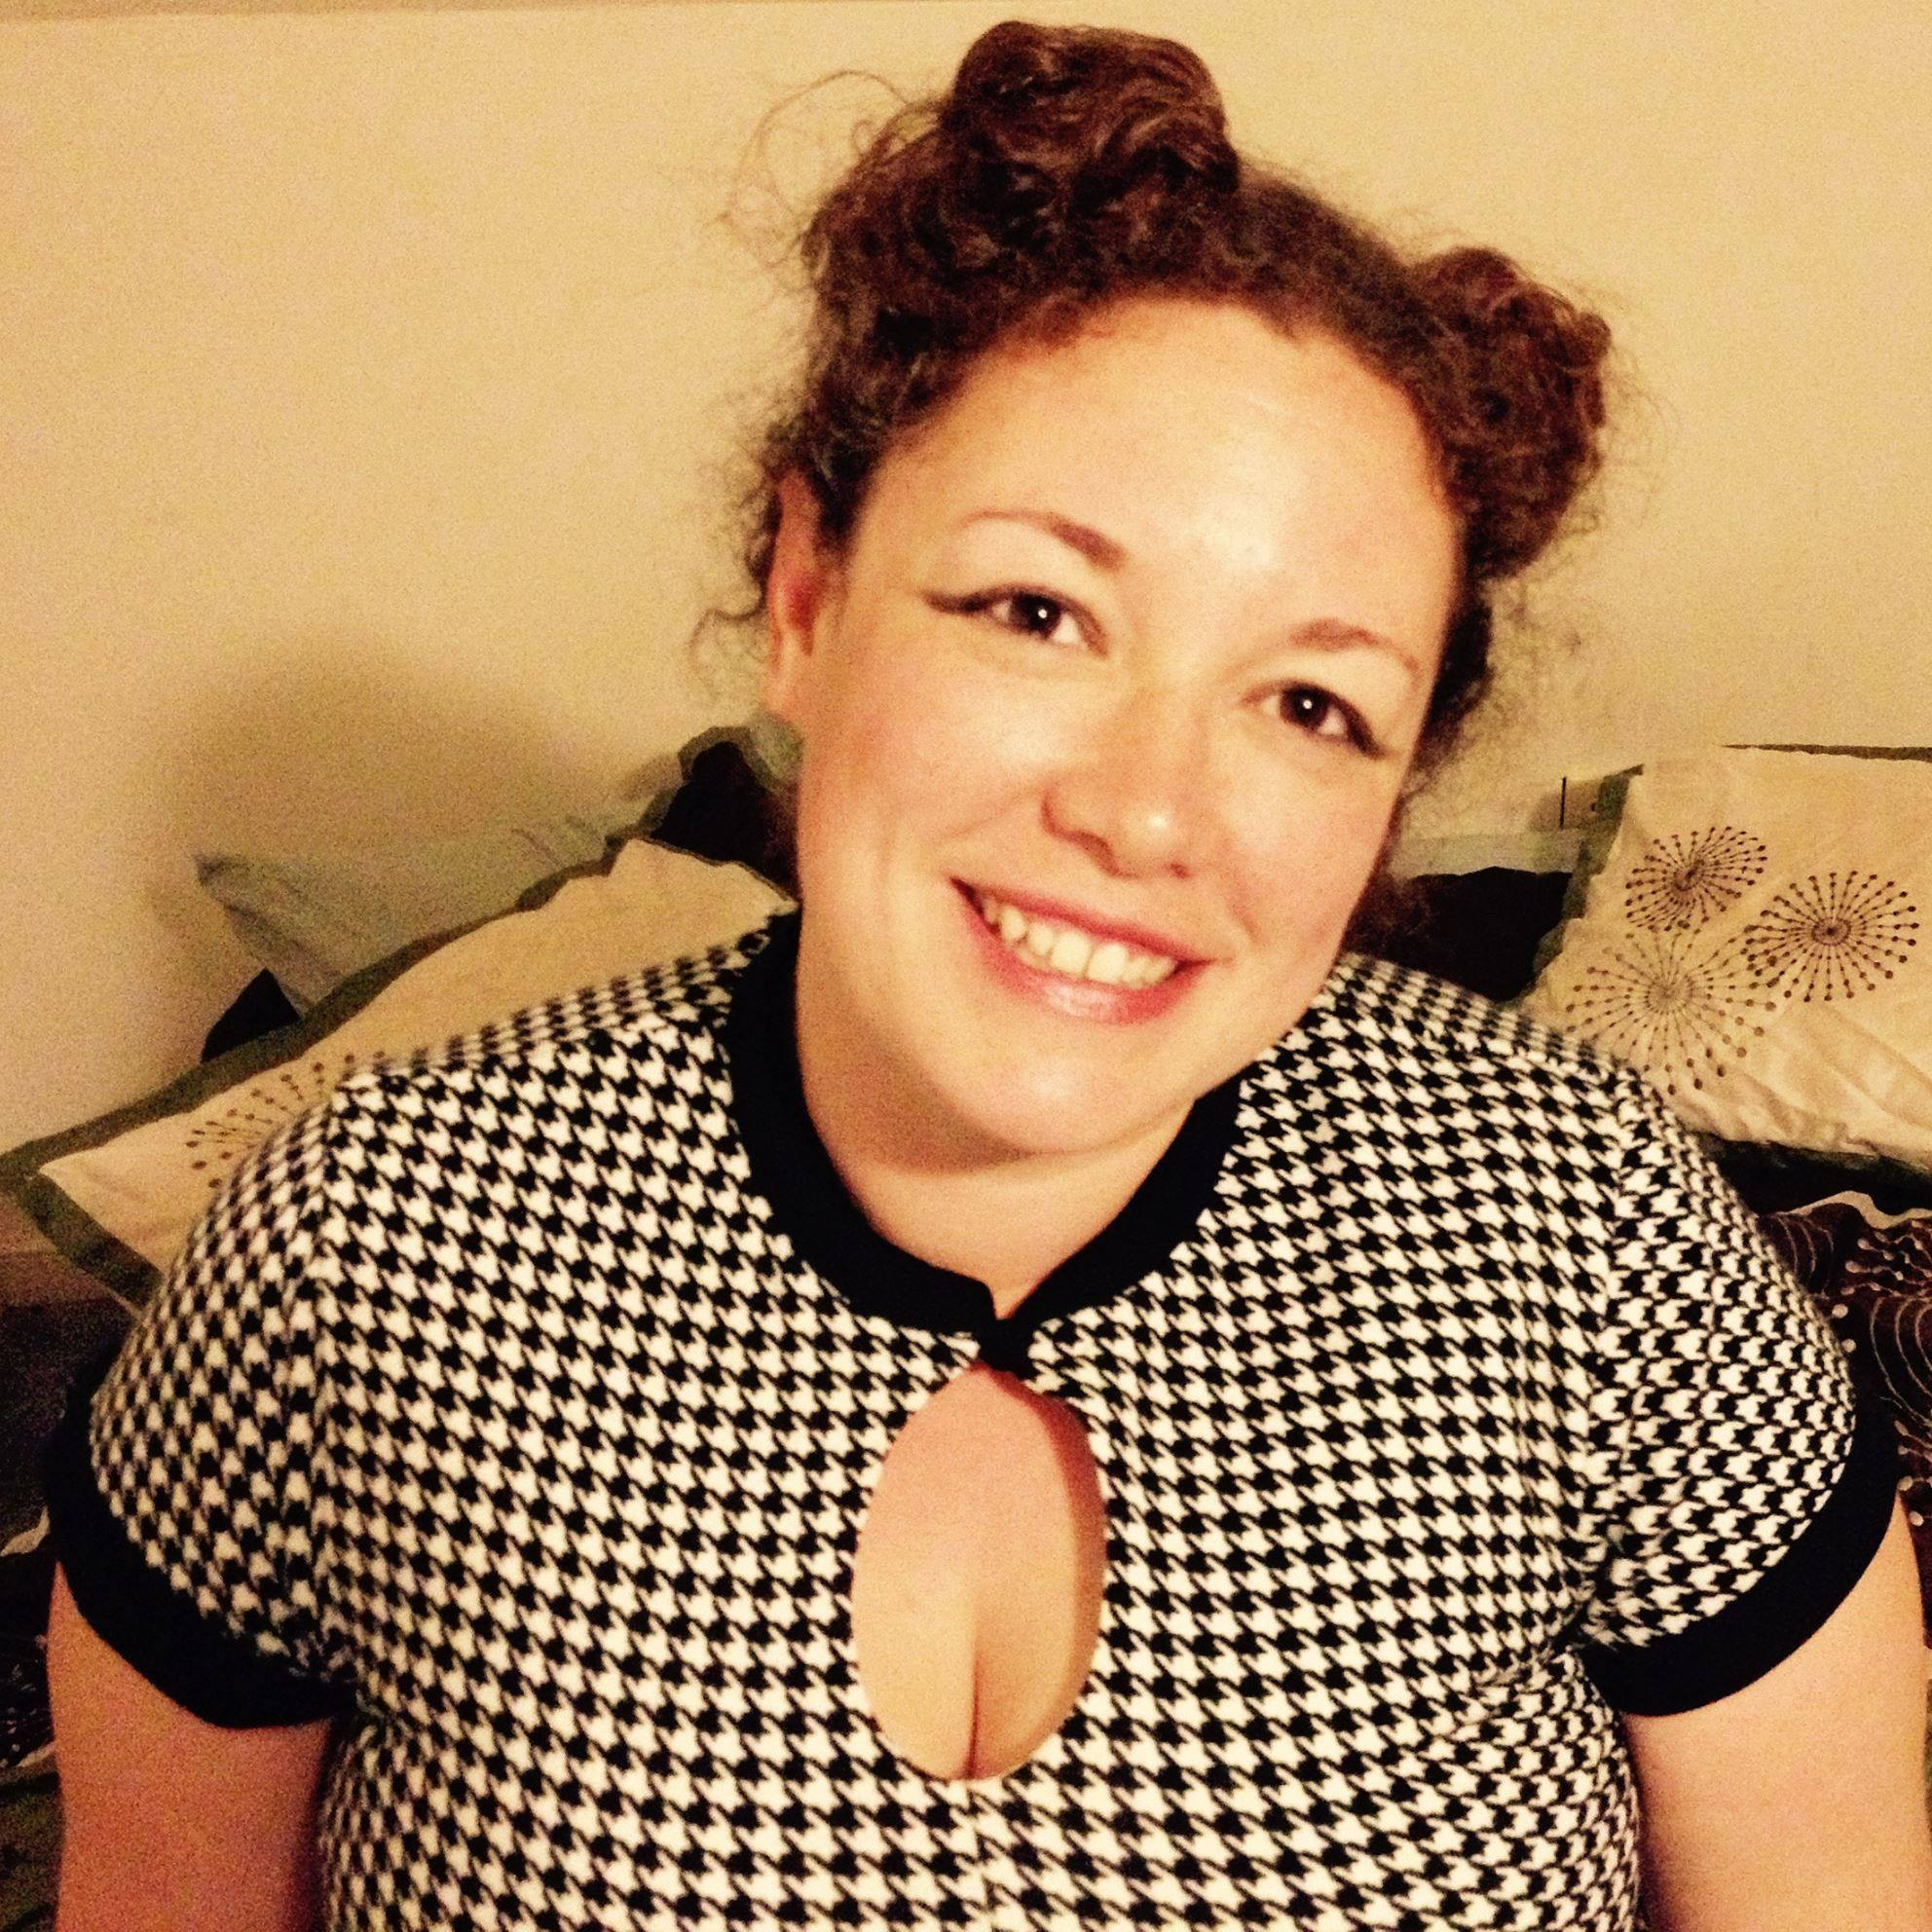
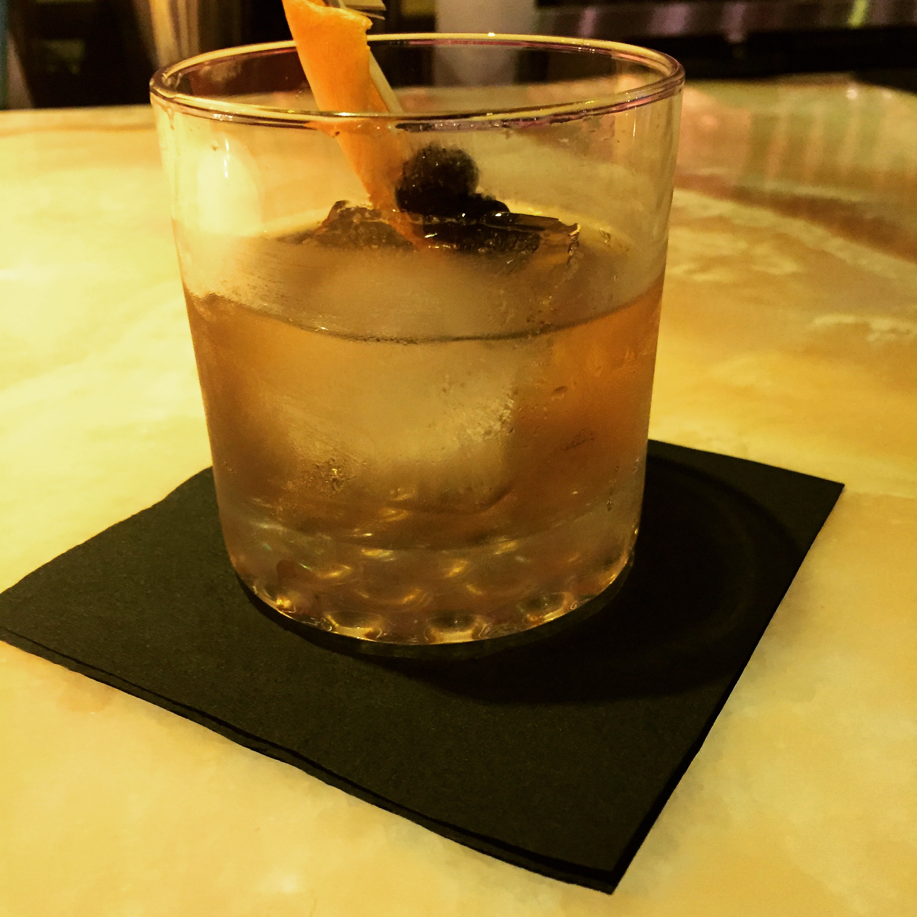
services
sponsored posts & links
recipe development
historic recipe research
food photography
partnership packages

Work With Me.

I’d love to review your specialty and artisan food products. I’m happy to develop an interesting recipe for your brand. I love attending and covering food events. I’m very brand-friendly, as long as your brand has a unique voice and an authentic and interesting story.
collaborations

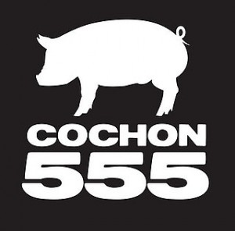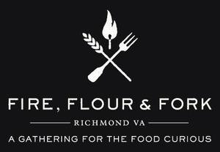
About Dogwood Dispatches

Dogwood Dispatches is a lifestyle blog covering culinary history, local foods and beverages, classic cocktails and travel. As a Southern Gothic lifestyle blog, Dogwood Dispatches shares the life of a suburban mom, wife and foodie with an penchant for a southern gothic aesthetic.
community

Pageviews:
300/month

Facebook:
250

Pinterest:
766

Twitter:
886

Instagram:
198

About Me

I’m a wife and mom of three children and one French bulldog. I work in the liquor industry and have a passion for culinary history, cooking, traveling, cocktail culture, reading, writing and art.

www.dogwooddispatches.com
rsbryswrrl@gmail.com
facebook.com/rsbryswrrl
twitter.com/rsbryswrrl
instagram.com/rsbryswrrl

audience

My blog and social media followers are drawn to culinary history and unique food experiences. My most popular posts are local and regional restaurant reviews and Southern food content. The majority of my blog’s readers are 18-34 years old.
MEDIA KIT

